Relaxing Hand massage
You will need
•A cushion protected by a towel
•A suitable oil such as Sunflower oil (cooking oils)will be perfect no need for anything fancy
•Pour some oil into a small container/ jug/cup because if you need more out during the massage handling a bottle is tricky!
• Have kitchen roll , tissues or extra towels to wipe your hands
•Avoid using any oils that will irritate your skin ( you know what is suitable for yourself)
•Hand cream will absorb to quickly making them difficult to use
•Be comfortably seated- at a table will be easiest
• You will find out how to energise yourself & release tension throughout the body
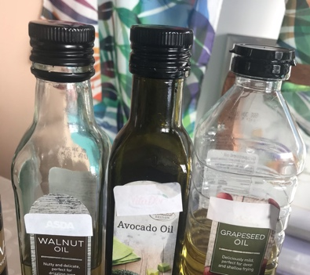
• A nice warm cuppa️!
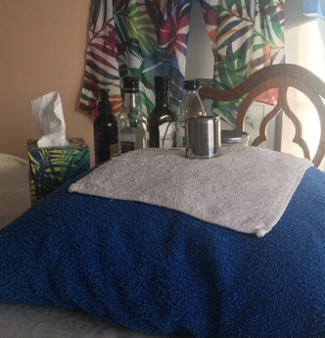
For more information contact me on Facebook
•Mary-Jane Burns
•The Holistic Health & Wellbeing Company CIC
•Mary Jane Tropic Skincare
Or Email
maryjane.wellbeing@gmail.com

